Ypsilanti Automotive Heritage Museum and
The National Hudson Motor Car Company Museum
will have Special Hours During the Hudson International Meet

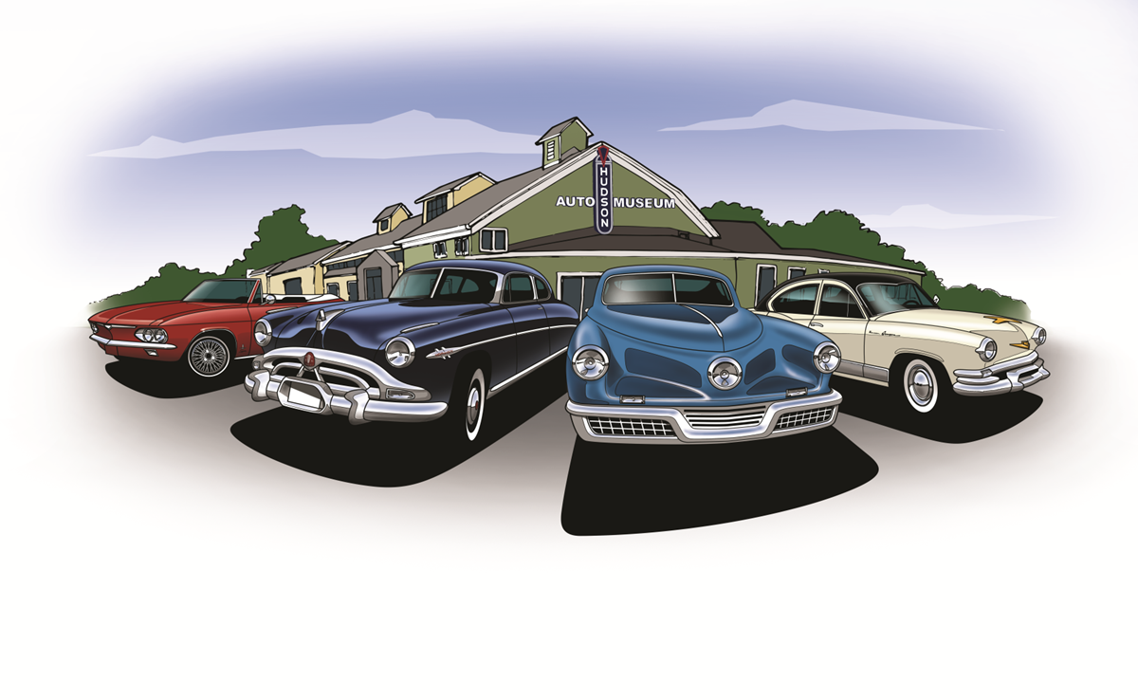
Saturday, July 23rd 1 pm – 4 pm
Sunday, July 24th 1 pm – 4 pm
Tuesday, July 26th 1 pm – 4 pm
Wednesday, July 27th 1 pm – 4 pm
Cruise Night is on Wednesday from 6pm – 8pm hosted by the Museum
Thursday, July 28th Open House 4 pm – 7:30 pm
Friday, July 29th 1 pm – 4 pm
Saturday, July 30th 1 pm – 4 pm
Sunday, July 31st 1 pm – 4 pm

